DECIMAL TO OCTAL

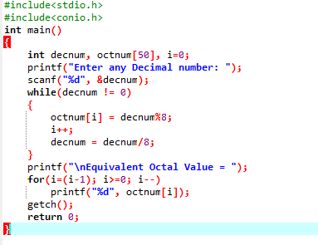

OUTPUT

